
Home Banking
Sign Up Walkthrough

Here are the instructions on how to sign up for Altonized Community FCU home banking.

- Go to the Credit Union website at www.altonizedfcu.org

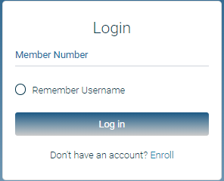

- First time users will need to select “Enroll”. They will need to enter their member number, email address, postal code, and birth date. They will then need to click the box to acknowledge the User Agreement and click the box labeled “Sign Up”.

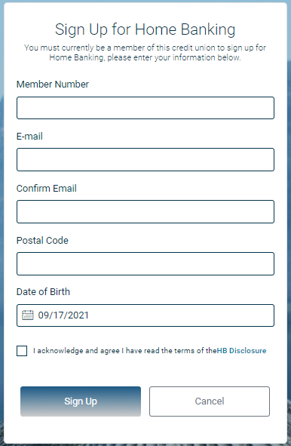

NOTE: You do not need to have an email address on file with the credit union in order to enroll in home banking. However, if any other information above doesn’t match what is on file, you will get the following message.

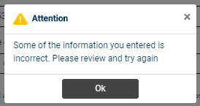

If you are certain that the information being entered to enroll is accurate - you will need to contact the CU and have them correct the information in your Member Properties.

- If all of the information is acceptable – once you click on the “sign up” button – you will receive the following pop-up and be sent back to the front page.

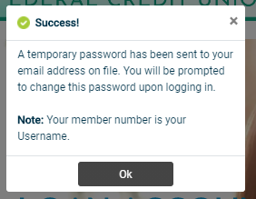

The email will look like this. NOTE: if you do not receive this email, check your spam folders.

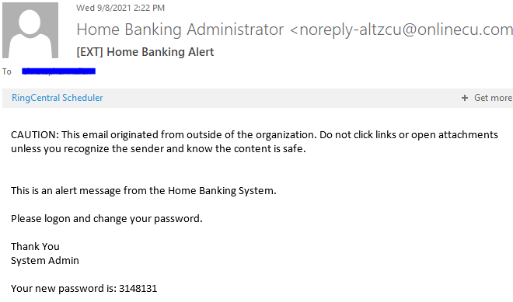

- Using your member number for the username and the temporary password sent to your email, you should log back into home banking. This will now prompt the user to update their password. The new password should contain Uppercase, Lowercase, Numbers, Special Characters, and a minimum length of 8 characters.

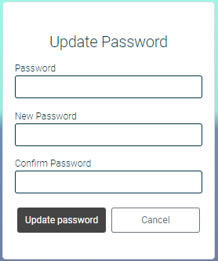

Should the new password not meet the Credit Unions required standards of a password, you will get this message when you hit “Update password”

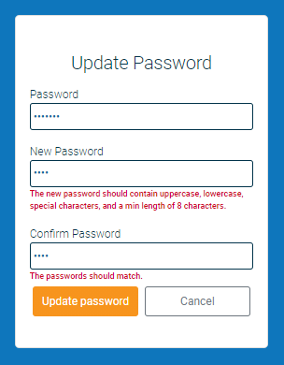

- You will then have to answer a series of three authentication questions and select a “confidence word”. There is a choice of different authentication questions if you select the arrow next to each question. After selecting the desired question, please input your desired answer.
  - If you log-in from another computer, the system will make you answer one of your Authentication Questions to verify who they are.
  - Confidence Word: This is a word or phrase that will show on their log-in screen to let you know that you have come to the authentic site for Home Banking.

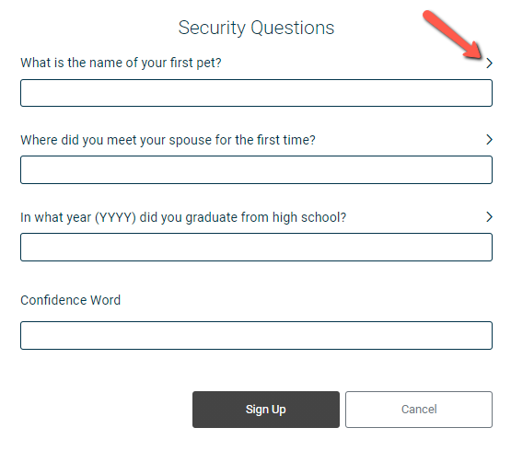
- After completing Authentication Questions, you should automatically be signed into your home banking.



